Victim: Rxxxx Dxxxxxxxx incident addendum
Date of incident: October 7, 2014
Time of incident: Approximately 11:22 AM
Location of incident: US 60 9674 Sturgis, KY.
Incident report prepared by: GM, Member Systems Safety and Training Director.
As described by the three witnesses:
The four man crew; consisting of TF, KB, EW, and RD had connected a service to a previously set pole and where in the process of connecting the #2 overhead triplex conductor to an existing C1 primary pole with a 15KVA transformer that fed an existing triplex running to a service on the west side of US 60.
RD was working out of a bucket truck #512, a 55ft. Terex HiRanger. A man on the ground had pulled up the Triplex on a handline and RD deadended it in a wedge clamp. KB noted the triplex was too low and two men on the ground pulled on the handline while RD redeadended the triplex and it was noted by the employees on the ground that RD had his rubber gloves on at that time.
The ground personnel went on to other duties as RD proceeded to make up the triplex at the transformer and at some point removed his rubber gloves while making a neutral termination at a terminal pin (pigtail) at the X2 bushing of the transformer. Apparently RD; in attempting to use a compression tool to squeeze the #2 neutral into a connector already in place in the X2 (center, secondary) bushing of the 15KVA transformer, separated the handles of the tool far enough to make contact with the primary stinger of transformer. Contact was made with the back of his left hand at the same time his right hand was in contact with the secondary neutral at ground potential
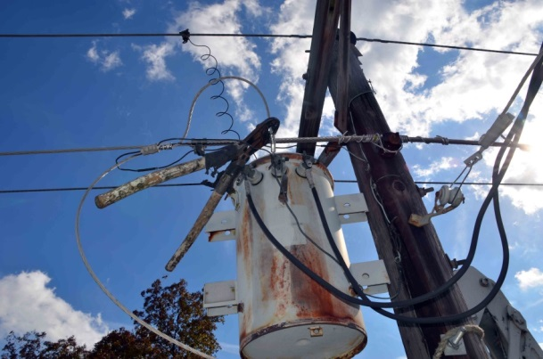
(See picture #1).

RD incident addendum
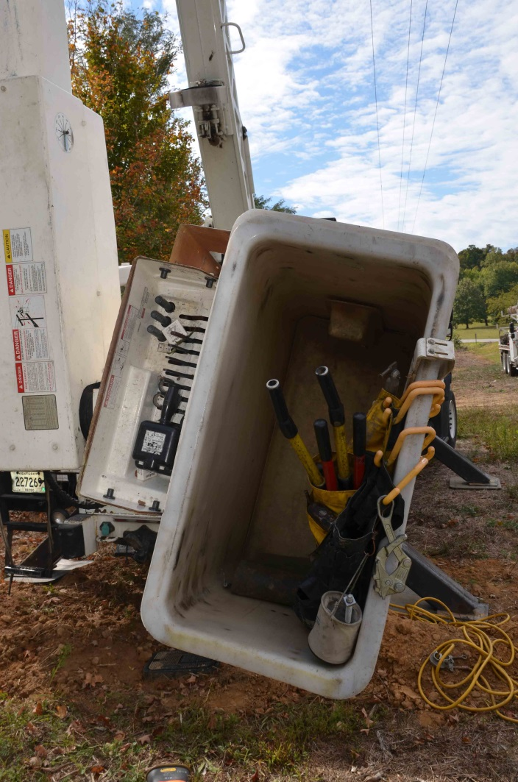
Each witness reported hearing an electric arc and seeing a flash as RD went limp in the bucket. TF went to the lower controls and lowered the bucket to the back of the unit #512.

(See picture #2).

KB used his cell phone to call 911.
EW, with the help of KB pulled RD (a 320 pound man) from the bucket. Using the bucket tilt method of bucket rescue; the men had difficulty getting the lanyard snap free from the bucket so Kevin cut the lanyard allowing Rhyan to be removed from the bucket. Rhyan, was placed on his back, in the gravel; being careful not to injure his head.

EW checked for a pulse and finding none started CPR. KB retrieved the AED from his pickup and TF assisted in connecting the Electrodes of the AED to RD’s chest while CPR was continued. The employees noted that Rhyan’s color had turned blue as they performed CPR. The machine advised a shock which TF administered when everyone was clear. The machine advised deeper CPR compressions and later a second shock. Then the machine advised continuing CPR and later advised the rescuers to clear and administer a third shock at which time RD took a breath and moved his arm. The machine advised continuing CPR for a short time.
When the Ambulance arrived from Marion, RD was somewhat coherent. The ambulance crew changed the AED out to the one from their unit and loaded RD. KB rode to the emergency room in the ambulance with RD.

Picture #3: the general location of RD and the CPR.
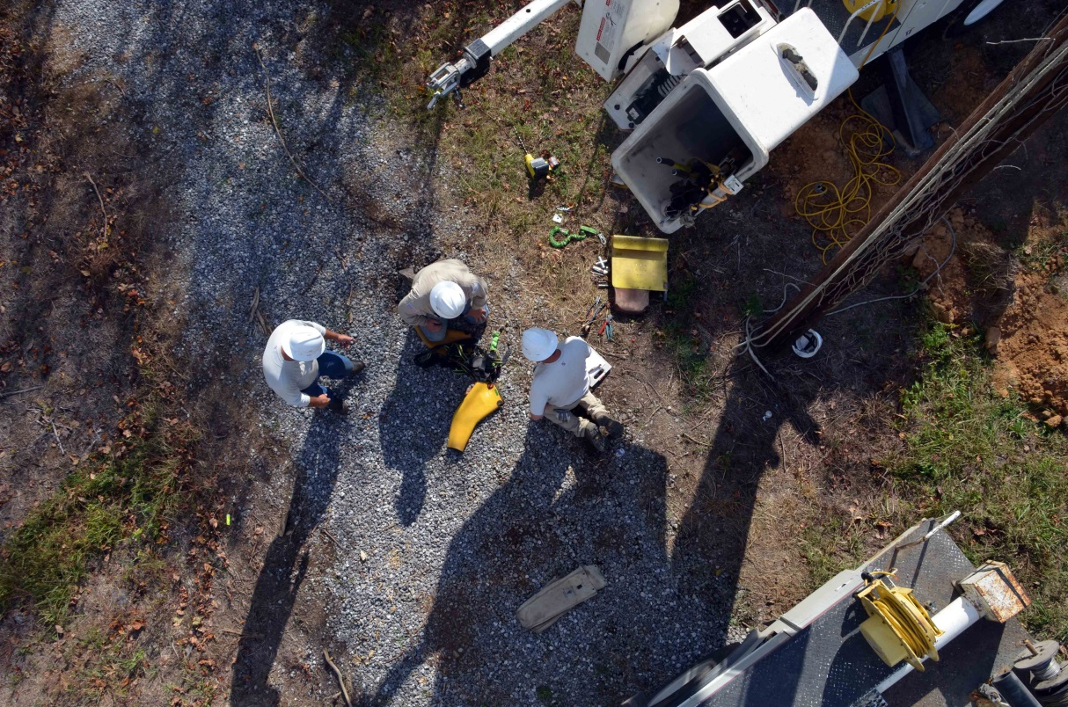

Picture #4: right hand contact point on the triplex neutral.
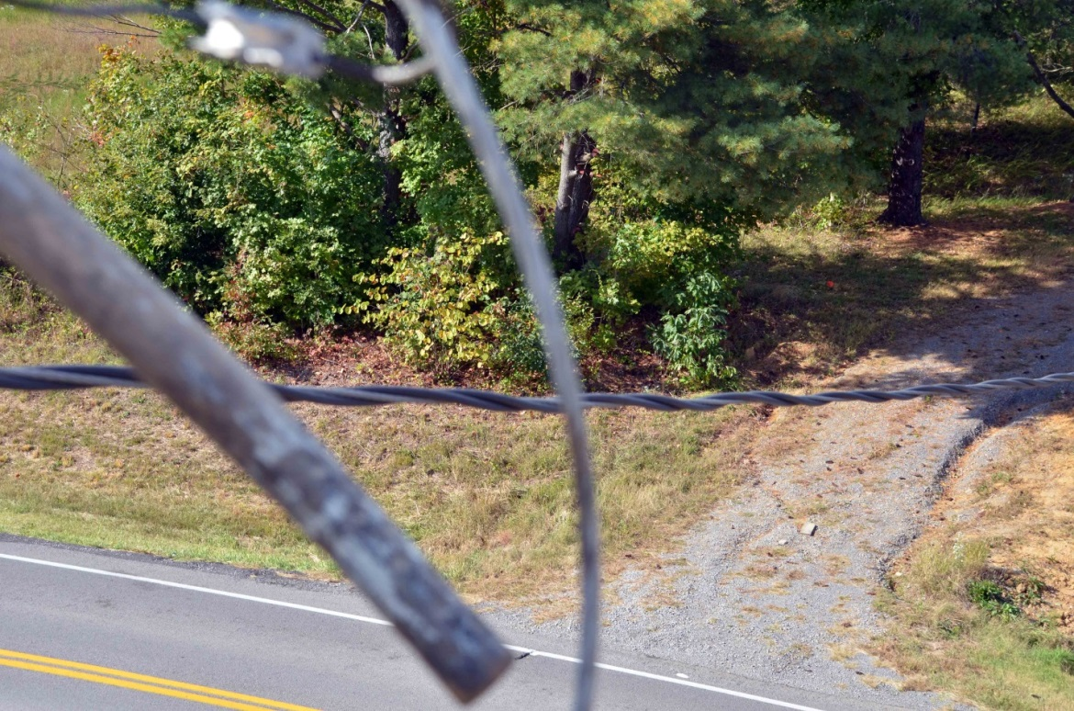

Picture #5: left hand contact point at the first loop of the primary stinger.
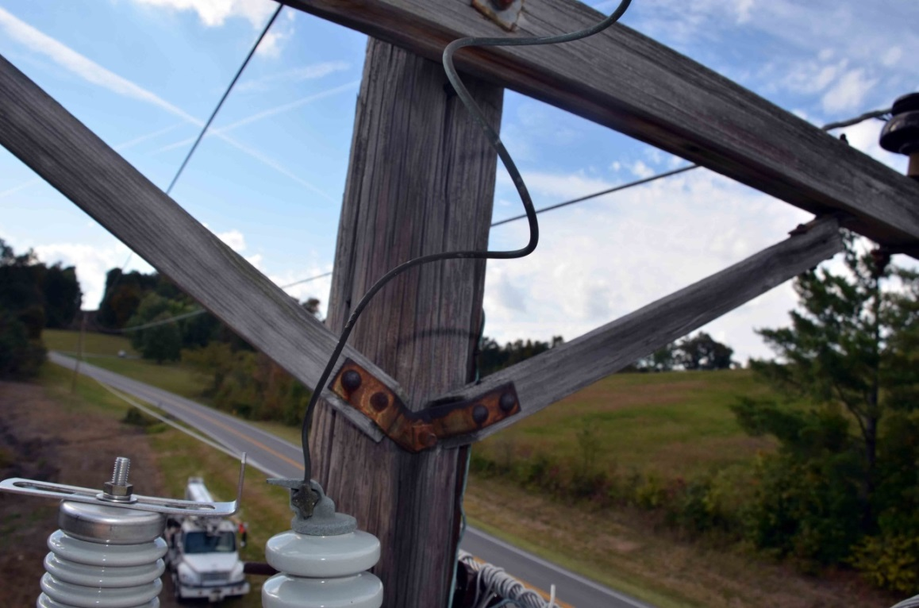

Picture #6: incident scene
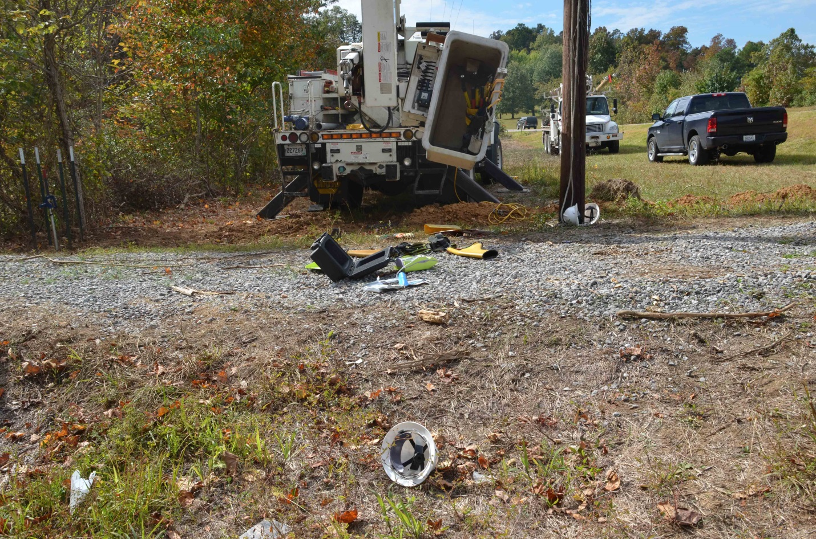
Picture #7: approximately 32 inches between contact point.
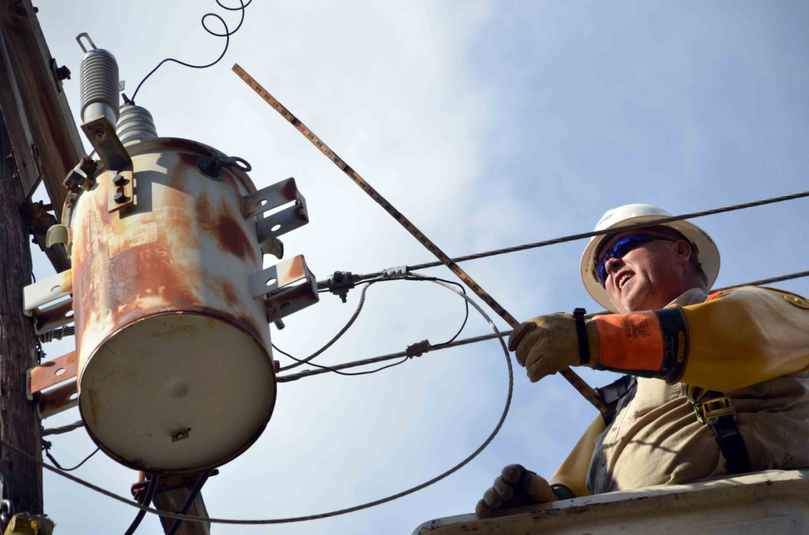

Picture #8: the incident scene looking under the 3-phase line from south to north.
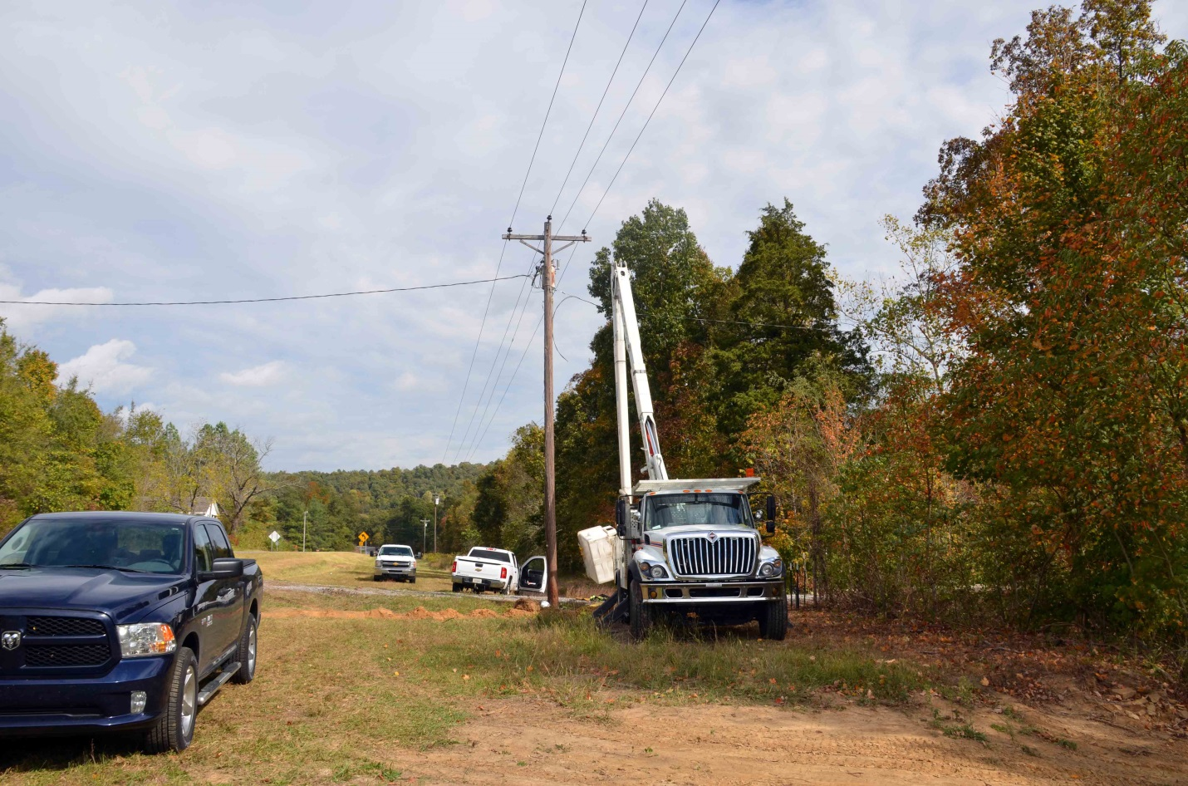
Picture #9: the incident scene looking under the 3-phase line from north to south.
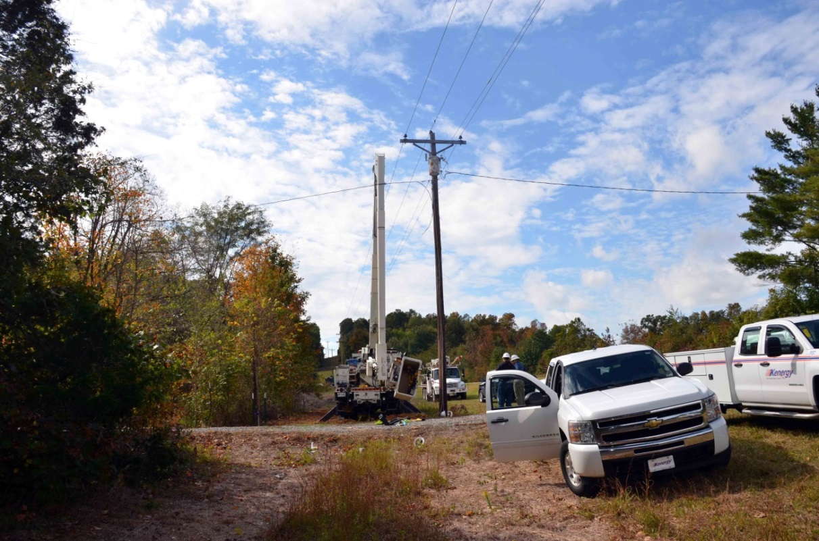

Picture #10: east to west from the new service pole.
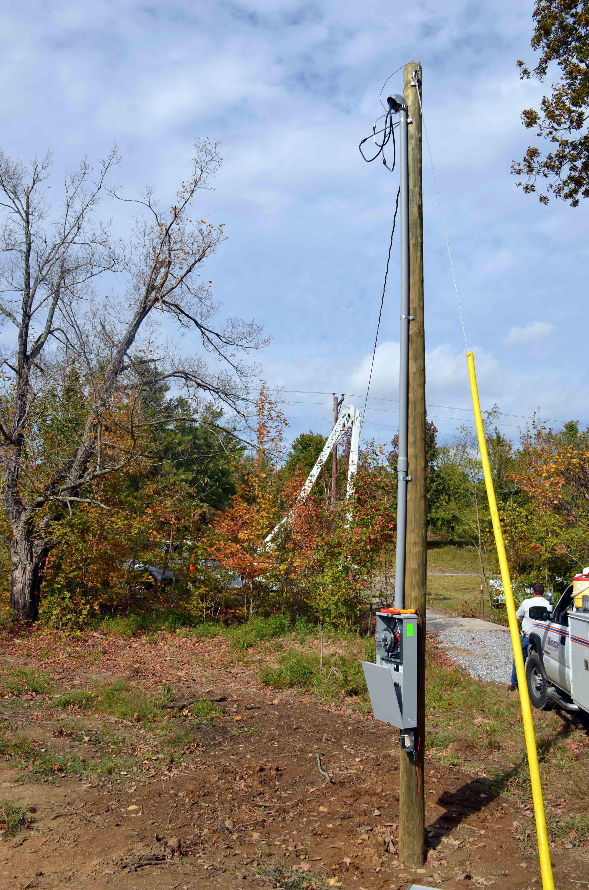

Picture #11: lose gloves at the incident scene.
